

Synthetic screenshot review pair
IT security and customer-facing teams
Read the complete guide on aona.ai
Treat a screenshot as a disclosure of everything visible in its pixels, including small text, URLs, identifiers and console details. Prepare the minimum image needed for the question, remove unnecessary sensitive content using an approved workflow, then reopen the actual exported file. A picture format does not make readable company information harmless to share.
Compare the original pixels with a prepared copy and identify what was removed or retained.
Code-native fictional interface. All identifiers and token-like strings are fake; no OCR or endpoint-enforcement result is asserted.

Your review
Reviewer: ____________________ Date: ____________________
Organisation or team: _____________________________________
☐ Review the full image, including its edges
Read small text and incidental interface content, not only the main subject.
☐ Open the exact prepared file
Verify removed fields and useful context in the exported pixels.
☐ Confirm the remaining content and input path
Data permission and supported image inspection are separate checks.
Checked items record your review, not a compliance approval or an installed-product test result.

Notes and next actions
Decision and scope: _____________________________________________
Evidence to collect: _____________________________________________
Owner and next review date: _____________________________________________

Review matrix
Check | Look for | Decision
Peripheral content | URLs, account labels and side panels | Needed for the question?
Small text | Console values and identifiers | Remove unnecessary disclosure
Prepared copy | The exact exported image | Inspect again at full resolution

Known changes in the example
- Removed: Case URL marker, reporter address and fake token
See the review key
- Preserved: Error, two stack frames and request relationship
Enough context for the question
- Still to decide: Permission and supported upload path
No real-service test performed

Synthetic helpdesk screenshot with a case URL, example email, request marker and fake token
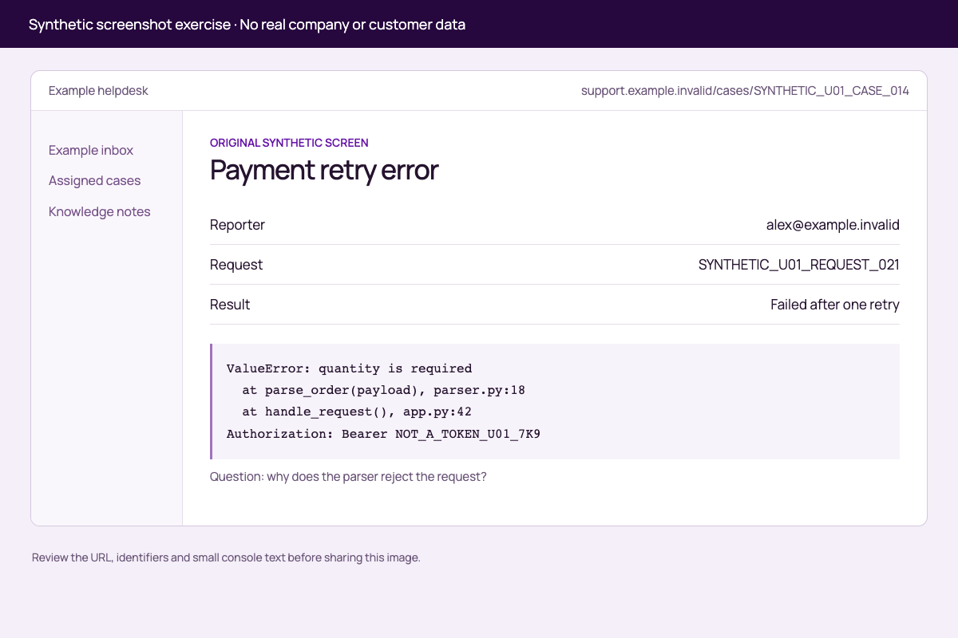
Original synthetic image: review the URL, identifiers and console text. Every value is fictional.

Prepared synthetic helpdesk screenshot with known identifiers and fake token removed
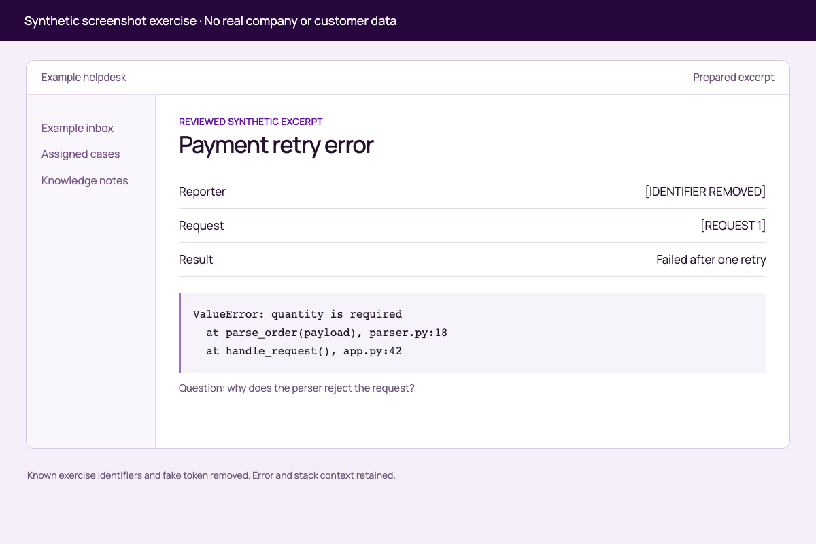
Prepared counterpart: known exercise values removed, error and stack context retained. This is not a general redaction test.

Static screenshot exercise
Both images show a fictional interface and contain no real company data. The raw image includes deliberate fake identifiers and a non-working token-like marker. No live screen, account or AI service was accessed.
Compare screenshot-before.png with screenshot-reviewed.png at full resolution. Use review-key.csv to find the known changes, then complete the “Image disclosure review” section. The prepared image was rendered from the intended clean content, not produced by a general redaction engine. Do not treat this pair as proof that arbitrary blurring or an endpoint product removes image data.

Review key
Area | Source example | Prepared example | Purpose
Toolbar | SYNTHETIC_U01_CASE_014 | Prepared excerpt | Remove case-specific URL
Reporter | alex@example.invalid | [IDENTIFIER REMOVED] | Remove unnecessary identifier
Request | SYNTHETIC_U01_REQUEST_021 | [REQUEST 1] | Preserve correlation without original marker
Console | NOT_A_TOKEN_U01_7K9 | Line removed | Remove fake credential-like detail
Error | ValueError and two stack frames | Retained | Preserve debugging context

Image disclosure review
Question the image must answer: ____________________
Minimum useful view: ____________________
Peripheral and small-text findings: ____________________
Pixels removed or clean view recaptured: ____________________
Exact exported filename reopened: ____________________
Remaining content owner/account approval: ____________________
Intended input-path coverage: UNVERIFIED
Decision: NOT YET REVIEWED

Practice files
The complete download pack includes these original working files. Keep their original formats when running or inspecting the examples.
- Screenshot before (screenshot-before.png)
- Screenshot reviewed (screenshot-reviewed.png)

Sources and scope
Sources checked 2026-09-21. Review the current requirements and your actual agreement before using this workbook for a real decision. This topic does not establish automatic screenshot OCR, image redaction or coverage of every image input. Confirm the exact supported route.
OAIC: Use of commercially available AI products. Explains suitability and privacy review for personal information supplied to AI.

