

Synthetic screen-sharing session exercise
IT security and employee enablement
Read the complete guide on aona.ai
Confirm the actual screen-sharing scope, indicator and stop control before showing a work screen to an AI assistant. Content can change during the session, including unrelated windows and notifications. Verify that sharing has stopped through the selected app’s controls; muting the microphone alone may leave screen or video sharing active.
Review a changing screen, a new notification and the intended stop state before an actual company session.
Fictional interface images only. No screen permission, live capture or provider session was created.

Your review
Reviewer: ____________________ Date: ____________________
Organisation or team: _____________________________________
☐ Record the actual sharing scope and controls
Use the selected app’s supported options, not the fictional image buttons.
☐ Account for new windows and notifications
Review content that can appear after the session starts.
☐ Verify stop separately from microphone mute
Check the actual indicator and any standing permission; do not infer deletion of prior content.
Checked items record your review, not a compliance approval or an installed-product test result.

Notes and next actions
Decision and scope: _____________________________________________
Evidence to collect: _____________________________________________
Owner and next review date: _____________________________________________

Review matrix
Stage | Worked exercise | Observed live result
Before | Review the fictional window and sidebar | Untested
During | Notification introduces a new marker | Untested
Stop | Example indicator says sharing stopped | Untested

A session changes over time
- Before: Prepare the intended view and remove unrelated material
Scope is a current app setting
- During: New content can appear after sharing begins
The example notification is synthetic
- After: Verify the correct stop control and remaining permissions
Prior transmitted records are separate

Fictional desktop before sharing with a visible unrelated-window marker
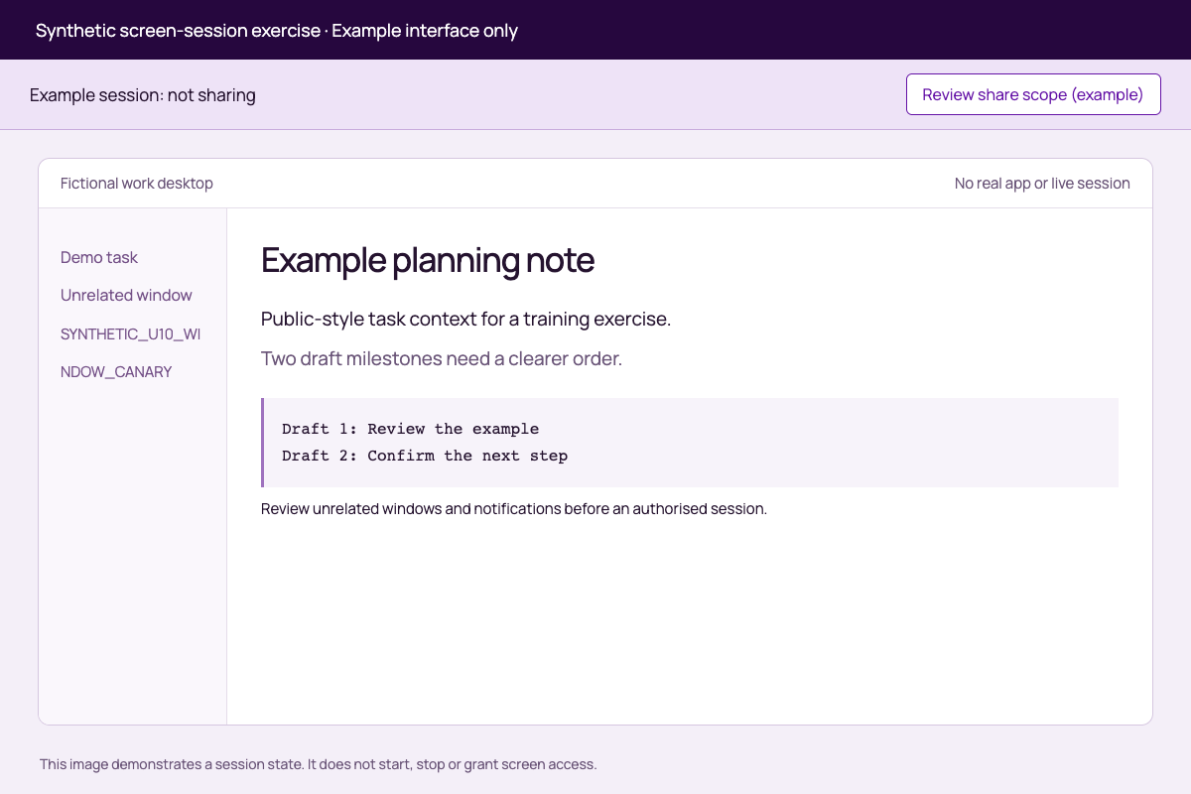
Before the example session: review the intended content and anything else that could become visible. No real screen is captured.

Fictional active sharing session with a newly arrived synthetic notification
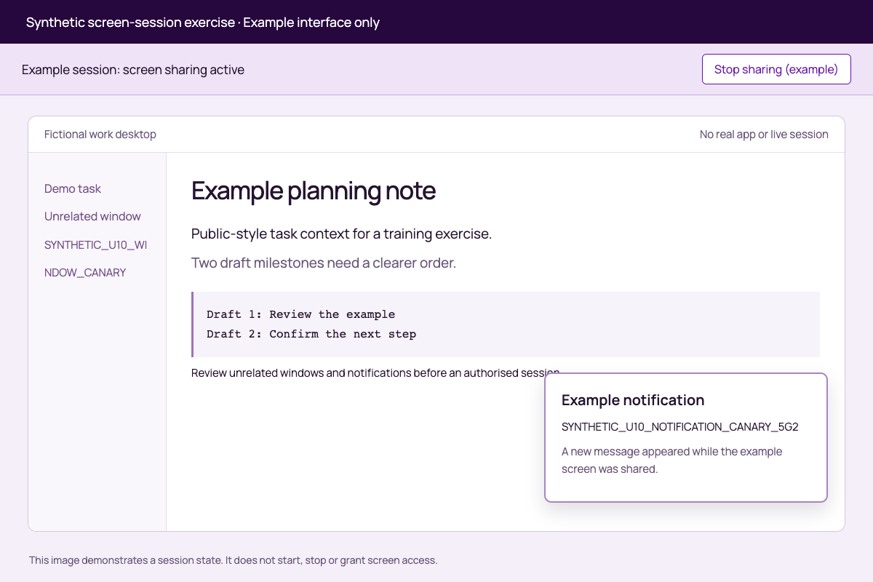
During the example session: a notification introduces new content after the initial review. This is an illustration, not an AI capture result.

Fictional desktop with the example sharing indicator set to stopped
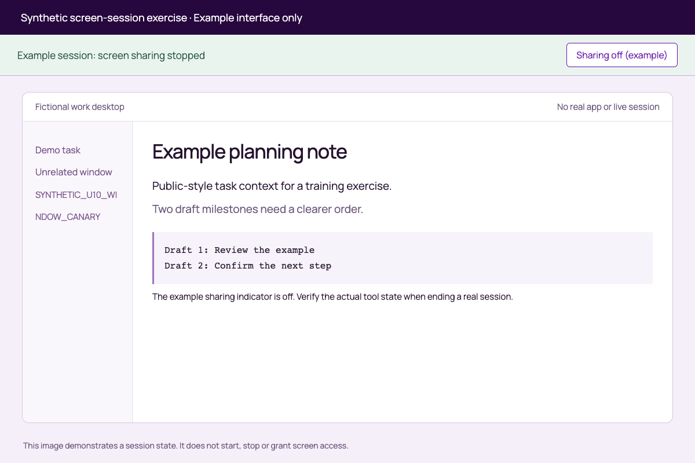
Stopped example: verify the actual product’s sharing state separately from microphone mute and retained records.

Synthetic screen-session exercise
The three PNGs show a fictional interface created from code. They do not depict a real Gemini or ChatGPT session, capture a device screen or grant permissions. All markers are synthetic. The buttons in the images are illustrations only.
Compare before-sharing.png, during-sharing-notification.png and sharing-stopped.png. Notice the unrelated-window marker and the notification appearing after start. Use session-review.csv to record the actual product controls in any authorised synthetic rehearsal. Never use confidential company content merely to test a sharing boundary.
Google’s Gemini Live Android documentation is one source example: microphone mute does not by itself stop screen/video sharing. Check the actual client’s current controls.

Session review
Stage | Worked synthetic scenario | Actual app control or scope | Observed result | Evidence
Before | Fictional planning window plus unrelated sidebar | RECORD | UNTESTED
Start | Only the approved synthetic view should be shared | RECORD | UNTESTED
During | SYNTHETIC_U10_NOTIFICATION_CANARY_5G2 appears | RECORD RESPONSE TO NEW CONTENT | UNTESTED
Mute | Do not assume the screen channel stops | RECORD ACTUAL BEHAVIOUR | UNTESTED
Stop | Verify the sharing indicator and correct channel | RECORD | UNTESTED
After | Review standing permissions and prior records separately | RECORD | UNREVIEWED

Work-screen sharing decision
Assistant/client/account/device: ____________________
Supported share scope: ____________________
Permitted task and content: ____________________
Unrelated windows/notifications addressed: ____________________
Actual stop control and confirmation: ____________________
Standing permission review: ____________________
Retained-record questions: ____________________
Synthetic rehearsal result: UNTESTED
Decision: NOT YET REVIEWED

Practice files
The complete download pack includes these original working files. Keep their original formats when running or inspecting the examples.
- Before sharing (before-sharing.png)
- During sharing notification (during-sharing-notification.png)
- Sharing stopped (sharing-stopped.png)

Sources and scope
Sources checked 2026-09-21. Review the current requirements and your actual agreement before using this workbook for a real decision. This guide does not establish continuous screen/video inspection or control. A supported text or document path is not evidence of live-screen coverage.
Google: Gemini Live on Android. Documents screen/video sharing and the distinction between microphone mute and continued sharing on the stated platform.

